**LEGO Report Analysis**

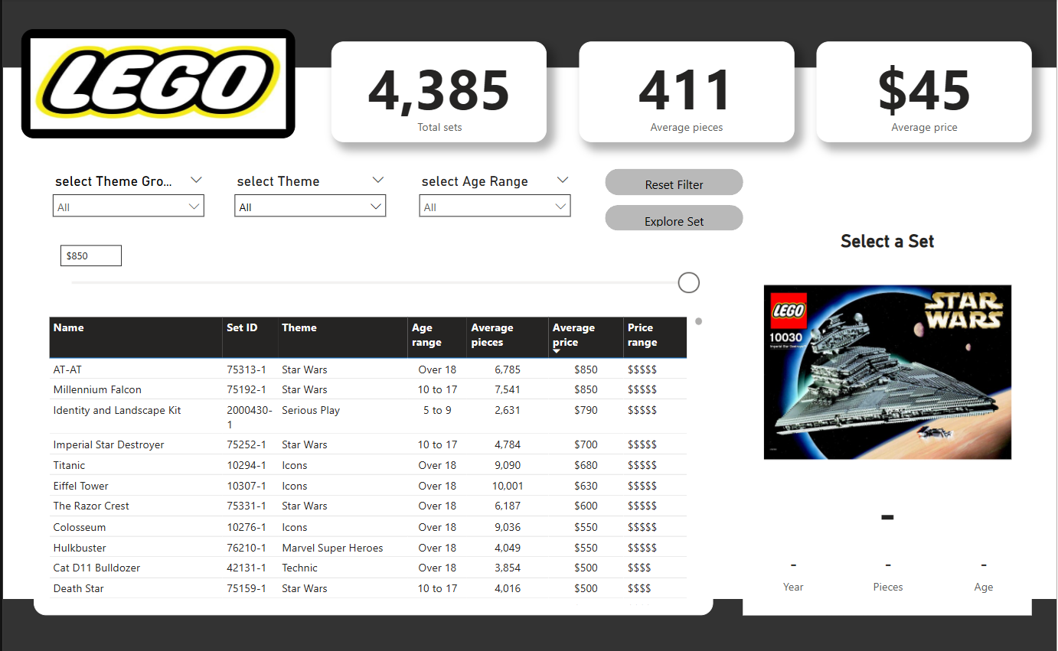

**🏢 Company Overview – LEGO Group**

The LEGO Group is a globally renowned toy manufacturing company best known for its signature interlocking plastic bricks, which have become a staple of imaginative play worldwide. Founded in 1932 in Billund, Denmark by Ole Kirk Christiansen, the company’s name is derived from the Danish phrase “Leg Godt,” meaning “Play Well.”

**🔧 What the Company Does:**

* Primary Business: Designing, manufacturing, and marketing of LEGO sets (plastic construction toys).
* Product Portfolio:
  + Themed LEGO sets (e.g., Star Wars, Marvel, Harry Potter)
  + Educational products (e.g., LEGO Education, LEGO Mindstorms robotics)
  + Entertainment (movies, mobile games, TV series)
  + Digital experiences (LEGO video games and augmented reality apps)
* Target Audience: Children, teenagers, adult collectors, and educators.

**🌐 Global Presence:**

* Headquarters: Billund, Denmark
* Operational Reach: Over 130 countries
* Retail Network:
  + 800+ LEGO-branded stores globally
  + Strategic partnerships with major retailers (e.g., Amazon, Walmart)
* Manufacturing Facilities: Located in Denmark, Czech Republic, Mexico, Hungary, China, and the U.S. (under development)

**🤝 Key Partnerships:**

* Global licensing agreements with top franchises:
  + Star Wars, Marvel, Disney, DC, Minecraft, and Harry Potter
* Educational collaborations with schools and STEM programs
* Media collaborations for animated films and series (e.g., *The LEGO Movie*)

**🌱 Commitment and Innovation:**

* Focus on sustainability, including:
  + Bioplastic bricks (from sugarcane)
  + Eco-friendly packaging
* Investments in digital transformation, AI, and data-driven decision-making
* Promotion of learning through play via LEGO Foundation initiatives

1. **Introduction**

The LEGO report provides a detailed analysis of the LEGO set database, covering essential metrics such as total sets, average piece count, price distribution, and categorical breakdowns. This report aims to offer insights into LEGO's diverse product lineup, highlighting high-value sets, popular themes, and pricing trends.

1. **Data Sources and Requirements** :

The data presented in this report is sourced from the official LEGO dataset, which includes:

* LEGO’s internal product catalog and sales data.
* Historical records of LEGO set releases and pricing trends.
* Market insights from LEGO’s digital archives and customer reports.
* Verified third-party LEGO databases that track set information.

**Requirements:**

* Perform a data-driven analysis using Power BI.
* Cover essential metrics such as:
  + Total number of LEGO sets
  + Average price and piece count
  + High-value set analysis
  + Categorization of themes and product types
* Include interactive Power BI elements like:
  + Tooltips
  + Page navigation
  + Filtering capabilities
* Demonstrate trend analysis and provide observations
* Mention any limitations in the data
* Conclude with actionable insights

**Key Statistics**

* Total Number of LEGO Sets: 4,385
* Average Number of Pieces per Set: 411
* Average Price of a LEGO Set: $45

These figures indicate that LEGO offers a wide range of products, catering to different interests, age groups, and budgets.

1. **High-Value LEGO Sets**

Several LEGO sets stand out due to their complexity, exclusivity, and price. The most expensive LEGO sets include:

* **AT-AT (75313-1, Star Wars)** – 6,785 pieces, priced at **$850**
* **Millennium Falcon (75192-1, Star Wars)** – 7,541 pieces, priced at **$850**
* **Identity and Landscape Kit (2000430-1, Serious Play)** – 2,631 pieces, priced at **$790**
* **Imperial Star Destroyer (75252-1, Star Wars)** – 4,784 pieces, priced at **$700**
* **Titanic (10294-1, Icons)** – 9,090 pieces, priced at **$680**
* **Eiffel Tower (10307-1, Icons)** – 10,001 pieces, priced at **$630**
* **The Razor Crest (75331-1, Star Wars)** – 6,187 pieces, priced at **$600**
* **Colosseum (10276-1, Icons)** – 9,036 pieces, priced at **$550**
* **Hulkbuster (76210-1, Marvel Super Heroes)** – 4,049 pieces, priced at **$550**
* **Cat D11 Bulldozer (42131-1, Technic)** – 3,854 pieces, priced at **$500**
* **Death Star (75159-1, Star Wars)** – 4,016 pieces, priced at **$500**

These high-end sets primarily belong to popular franchises like **Star Wars, Icons, and Technic**, demonstrating LEGO’s commitment to catering to both casual builders and dedicated collectors.

1. **Breakdown of LEGO Themes and Categories:**

LEGO sets are classified into different categories, with some of the most prominent ones including:

* **Licensed Sets:** 1,283 sets, featuring franchises such as Star Wars, Marvel, and Harry Potter.
* **Modern Day:** 725 sets, including city-based themes and real-world builds.
* **Action/Adventure:** 551 sets, covering LEGO’s narrative-driven themes such as Ninjago and Indiana Jones.
* **Miscellaneous:** 443 sets, containing varied themes that do not fit into other categories.
* **Model Making:** 320 sets, designed for enthusiasts interested in architectural and mechanical designs.
* **Pre-School:** 313 sets, including LEGO Duplo aimed at younger children.

Notable subcategories include:

* **City Advent Calendar:** 14 sets
* **Friends Advent Calendar:** 9 sets
* **Fire Station:** 5 sets
* **Police Station:** 5 sets
* **Cargo Train:** 3 sets
* **Fire Boat:** 3 sets

This diversity in themes highlights LEGO’s ability to attract a broad audience, from young children to adult fans.

**Tooltip**(Thumbnail):

**What is a Tooltip in Power BI?**

A **tooltip** in Power BI is a small pop-up box that appears when a user hovers over a visual element, such as a bar, point, or line in a chart. It provides additional details or insights related to the data point being examined. Tooltips enhance interactivity and improve data storytelling by allowing users to explore more information without cluttering the main visual.

**Types of Tooltips in Power BI**

1. **Default Tooltip**
   * Automatically generated when hovering over a data point.
   * Shows basic details like values and categories from the visual.
2. **Report Page Tooltip (Custom Tooltip)**
   * Allows users to design a dedicated report page as a tooltip.
   * Can include visuals, charts, and additional insights.
   * Provides more interactive and detailed information.
3. **Modern Tooltip** (Enhanced Tooltip)
   * Includes support for **dynamic formatting** and **additional metrics**.
   * Allows customized headers and multiple fields.

**How to Create a Custom Tooltip in Power BI**

**Step 1: Create a New Tooltip Page**

1. Go to **Power BI Desktop**.
2. Click on **"Page Navigator"** and select **"New Page"**.
3. Rename the page (e.g., "Tooltip Page").
4. In **Page Settings**, change **Page Type** to **Tooltip**.

**Step 2: Add Visuals to the Tooltip Page**

1. Drag and drop **charts, tables, or any visuals** onto the tooltip page.
2. Make sure the visuals provide meaningful insights for hover interactions.
3. Format the visuals to fit the small tooltip canvas.

**Step 3: Assign the Tooltip to a Visual**

1. Select the visual where you want the tooltip to appear.
2. Go to the **Format Pane** → Expand **Tooltip**.
3. Select **Report Page Tooltip** and choose the created tooltip page.
4. Hover over the visual to test the tooltip.

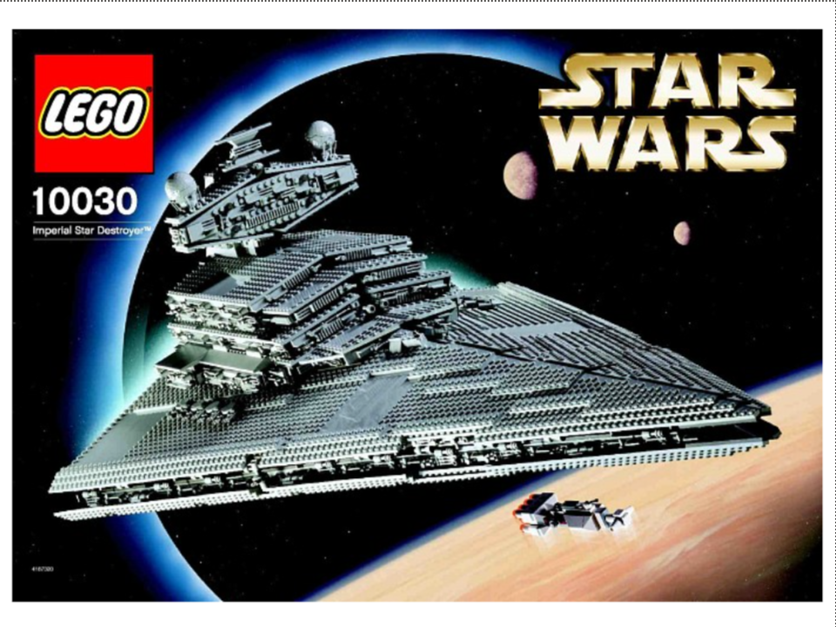

**6. Price and Piece Count Distribution** LEGO sets vary widely in both pricing and piece count, reflecting their complexity and target demographic. While the average set is priced at **$45**, many collector’s items exceed **$500**, offering intricate designs and exclusive pieces.

Sets with a higher piece count generally belong to advanced themes such as **Technic, Icons, and Star Wars**, with some exceeding **10,000 pieces**. The **Eiffel Tower (10307-1)** holds the record for the highest piece count at **10,001 pieces**, followed by the **Titanic (10294-1)** at **9,090 pieces**.

**7. Observations and Trends**

* LEGO continues to expand its **high-end collector series**, with premium sets attracting adult builders and enthusiasts.
* **Star Wars remains a dominant theme**, with multiple expensive and large-scale builds.
* **Model Making and Architecture sets are increasing**, suggesting a rising interest in real-world structures.
* **Licensed themes make up a significant portion of the catalog**, reflecting the company’s strategic partnerships.

**8. Limitations and Considerations:**

While this report provides a comprehensive view of LEGO’s product offerings, it is important to acknowledge potential limitations:

* Pricing and availability may fluctuate based on region and time of release.
* Limited edition and retired sets are not fully represented in current dataset trends.
* Some sets might be subject to variations in production, impacting the total piece count.

**Page Navigation**(Set Explore)

Power BI allows users to switch between different report pages seamlessly, improving report interactivity and user experience. It is especially useful for **multi-page reports**, **dashboards**, and **custom navigation menus**.

**Methods for Page Navigation in Power BI**

**1. Using Built-in Page Tabs (Default Method)**

* At the bottom of Power BI Desktop, report pages are displayed as tabs.
* Users can click on any tab to navigate between pages.
* This method is simple but **not interactive**.

**2. Using Buttons for Page Navigation (Recommended for Interactive Reports)**

Power BI allows you to create **navigation buttons** that take users to specific report pages when clicked.

**Steps to Create a Page Navigation Button:**

1. **Insert a Button**
   * Go to **"Insert"** → **"Buttons"** → Select **"Navigator" → "Page Navigator"**.
   * Power BI will automatically create a navigation menu with all page
   * Manually insert a button: **Insert** → **"Buttons"** → Choose any style (e.g., **Blank, Back, Next, Information**).
2. **Set Up Navigation Action**
   * Select the button, go to **"Format" pane**.
   * Under **"Action"**, toggle it **ON**.
   * Set **Type** to **"Page navigation"**.
   * Select the **destination page** from the dropdown.
3. **Test the Navigation**
   * Click **Ctrl + Click** in Power BI Desktop to test navigation.
   * In Power BI Service, clicking will directly take the user to the assigned page.

**3. Using Page Navigator Feature (Automatic Navigation Bar)**

* A built-in **Page Navigator** feature automatically creates a **navigation menu**.
* Go to **Insert → Buttons → Navigator → Page Navigator**.
* Power BI will generate a button-based menu with all report pages.
* You can customize button appearance, order, and visibility.

**4. Using Bookmarks for Advanced Navigation**

Bookmarks allow for **custom navigation workflows**, such as:

* Switching between pages.
* Changing views within the same page.
* Creating interactive dashboards.

**Steps to Use Bookmarks for Navigation:**

1. **Go to View → Enable Bookmarks Pane**.
2. Navigate to the target page and **click "Add"** to create a bookmark.
3. Assign the bookmark to a button by setting its **Action** to **"Bookmark"**.
4. Now, clicking the button will navigate to the bookmarked page or view.

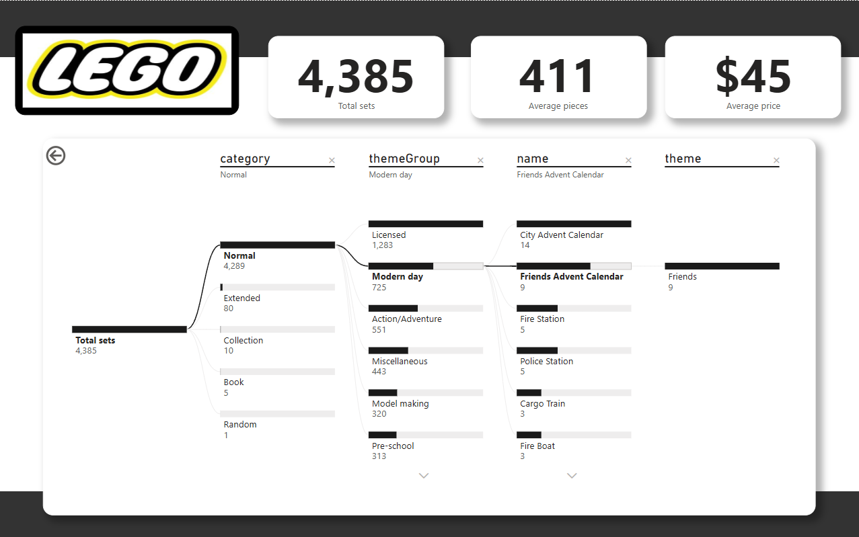

**Categorization of LEGO Sets:**

* **Normal Category:** 4,289 sets (majority of total sets)
* **Extended, Collection, Book, and Random Categories:** Combined, these make up a very small portion of the total (96 sets).

**Theme Group Distribution:**

* **Licensed:** 1,283 sets
* **Modern Day:** 725 sets
* **Action/Adventure:** 551 sets
* **Miscellaneous, Model Making, and Pre-School:** Combined, around 1,076 sets

**Deep Dive into "Friends Advent Calendar":**

* Falls under **"Modern Day"** theme group.
* A total of **9 sets** belong to this theme.
* Part of the **"Friends"** theme.

**Insights and Implications:**

* **High Concentration in Normal Category:** The vast majority of LEGO sets fall under the "Normal" category, meaning standard LEGO releases dominate.
* **Licensed Themes Have a Large Share:** With 1,283 sets, licensed themes (e.g., Star Wars, Marvel, Harry Potter) are a big portion of LEGO’s catalog.
* **Modern Day is a Significant Group:** With 725 sets, this group includes many contemporary city or lifestyle-related themes.
* **Friends Advent Calendar is a Niche Product:** Only 9 sets exist in this category, making it a specialized product for a particular audience.

**Conclusion**

These Power BI dashboards provide a **comprehensive visualization of LEGO set data**, enabling users to filter and explore sets based on various parameters such as **theme, category, age range, and price**.

**Key Metrics Overview:**

* The total number of LEGO sets available is **4,385**.
* The average number of pieces per set is **411**, and the average price is **$45**.
* These key performance indicators offer a **general understanding of LEGO’s product distribution**.

**Category & Theme Group Distribution:**

* The majority of LEGO sets (**4,289 sets**) belong to the **"Normal" category**, followed by minor categories such as **Extended (80 sets), Collection (10 sets), Books (5 sets), and Random (1 set)**.
* **Licensed sets (1,283 sets) are the most prevalent** within the "Normal" category.
* Other significant theme groups include **Modern Day (725 sets), Action/Adventure (551 sets), Miscellaneous (443 sets), Model Making (320 sets), and Pre-school (313 sets).**

**Filtering & Set Analysis:**

* Users can **refine their search using dropdown filters** for **theme group, theme, and age range**, as well as a **price input box** to set a budget.
* The dashboard currently highlights the **Friends Advent Calendar**, which consists of **9 sets** under the **"Friends" theme**, making it a smaller collection.
* Other themes under "Modern Day" include **City Advent Calendar (14 sets), Fire Station (5 sets), Police Station (5 sets), Cargo Train (3 sets), and Fire Boat (3 sets).**

**Dashboard Functionality & Interactivity:**

* The **interactive data table** lists LEGO sets along with **set ID, theme, age range, average pieces, and price range**.
* Selecting a set updates the **"Select a Set"** section, displaying a thumbnail for a **better visual reference**.
* **Navigation features** such as the **“Explore Set” button** likely provide a **detailed view** of the selected set, while the **"Reset Filter" button** allows users to **restore default settings**.

**Overall Insights:**

* The dashboards **efficiently categorize LEGO sets**, helping users explore trends based on theme, category, and pricing.
* **Licensed sets dominate the market**, while **Modern Day themes contribute significantly** to the total LEGO sets.
* The **Friends Advent Calendar** is a relatively **small but unique collection** within the **Modern Day category**.
* The dashboards are **well-structured, visually appealing, and interactive**, making them a **valuable tool for LEGO enthusiasts, collectors, and decision-makers**.

**Final Thought:**

These dashboards successfully enhance **data-driven decision-making** by allowing users to **filter, explore, and analyze LEGO sets efficiently**, making them **user-friendly and insightful for collectors and buyers**. 🚀